DevOps Lab

Troubleshooting Web Server issues
Home task

Prerequisites
IMPORTANT!! Please read task carefully. Current task should be performed using vagrant.
You have a broken site infrastructure (VM) which consists of:
- webserver (apache httpd)
- application server (apache tomcat)

SSH credentials of imported virtualbox machine are:
- Login: root
- Password: vagrant

There is no actual application deployed into tomcat.

TASK
You have to restore/fix tomcat default home page availability through httpd (port 80).

Once it’s done you are to fill table with found issues, put your investigations steps, define order of sorting all of this out, list utilities you used.

Files to be created during task execution:
- Fix script
- Modified Vagrantfile
- Fix report as PDF file

HOWTO

- Go to
- https://git.epam.com/epm-rdd1/Linux_DevOps_Lab/troubleshooting_task_1
or
- https://git.epam.com/epm-rdd1/Azure/troubleshooting_task_1
repository

- Create new branch from master with name accepting pattern Name_Surname:
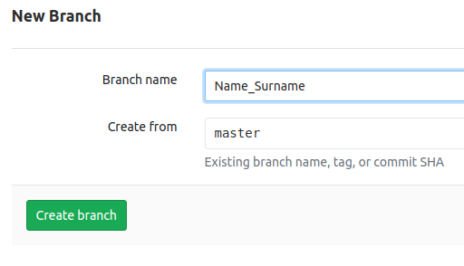
- Use your knowledge to create, clone, update and push your personal branch back to remote.

Acceptance criteria
- site is working;
- site will work after server reboot;
- firewall allows connections to 22 (ssh) and 80 (http) ports only;
- bash script which fixes issues is attached to the report;
- student understands what he/she deals with;

report pattern

# | Issue | How to find | Time to find | How to fix | Time to fix
1 | LoadModules troubles | $ httpd -t | 1 min | Include conf.modules.d/*.conf | 5 min
2 | Port 80 is in use by /usr/bin/nc | $ sudo netstat -tulpan | grep 80 | 1 min | sudo systemctl stop bindserver | 2 min
3 | Nc is reappearing after reboot | $ sudo systemctl | 1 min
4 | A suspicious cronjob forr root user | $ sudo crontab -l | 30 min | sudo crontab -r | 1 min
5 | Suspicious iptables REJECTs | $ sudo less /etc/sysconfig/iptables | 1 min | sudo iptables -F; | 1 min
6 | No firewall rules to allow connections from 80 and 22 only | $ sudo less /etc/sysconfig/iptables | 1 min | sudo iptables -A INPUT -m state --state NEW -p tcp --dport 22 -j ACCEPT; sudo iptables -A INPUT -m state --state NEW -p tcp --dport 80 -j ACCEPT;  sudo iptables -A INPUT -m state --state NEW -p tcp -j REJECT; sudo iptables-save | 2 min
7 | site rewrites its IP to an unrecognizeable DN | $ curl -L <SERVER_IP> | 1 min | Remove redirect from httpd.config in VirtualHost section | 1 min
8 | Tomcat is not running | $ ps le | grep tomcat | 1 min | Start tomcat.service | 1 min
9 | starting tomcat systemd service kills ssh connection and make it unavailable further | $ sudo systemctl start tomcat | 1 min | Remove “init 6” command from tomcat init file | 5 min

